' .
** RESERVATIONS ARE MADE WHEN PAYMENT IS RECEIVED**

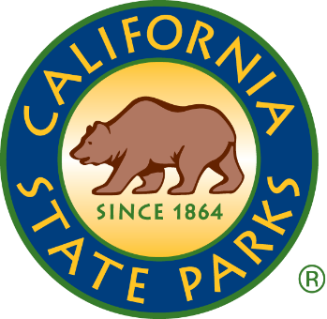
NORTH FOREBAY RAMADA RESERVATION FORM
California State Parks Northern Buttes District
400 Glen Drive
Oroville, CA 95966
Phone (530) 538-2200

NO REFUNDS FOR CANCELLATIONS
The four Ramadas at the North Forebay are available for reservation for a set fee per day. All participants
attending your function must pay the daily per-car fee. Because the North Forebay closes at sunset, the hours of use are limited from 8:00 AM to sunset. Please be aware that no lifeguard is provided. Electricity is not available.
NO DOGS ARE ALLOWED AT THE BEACH AREA DOGS MUST BE ON LEASH (6' OR SHORTER) AT ALL TIMES.
Name:
Address:
Phone:
Date of Event: Ramada Number(s): Number of people expected*:
(*50+ people require a Special Event Permit)
Purpose of event:
I have read the above conditions I agree to remove all party decorations including tape, tacks, food and trash from the Ramada before leaving the park. Failure to adequately clean the Ramada(s) may result in a cleaning charge.

Renter's Signature: _ _ _
>>>>>>>>>>>>>>>>>>>>>>>>>>>>>>>>>>>>>>>>>>>>>>>>>>>>>>>>>>>>>>>>>>>>>>>>>>>>>>
Thank you for visiting your 'California State Parks.
Please help by depositing all 'recyclable materials in the designated bins.
Receipt Number:

Total Received: Cash Credit Check – Check#:
Received By: Date:
(Employee)
Make (4) copies: Original: 1 to Renter: 1 to Maintenance: 1 to Park Aides: 1 to Binder

